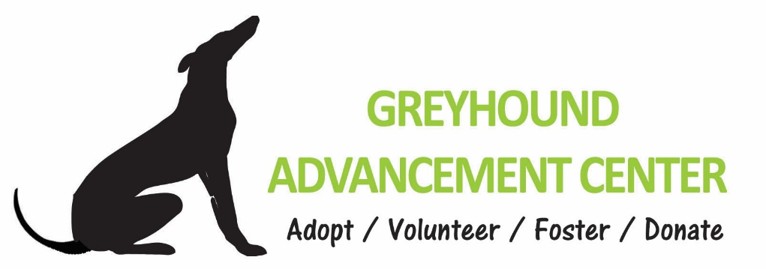
Many Thanks to our Veterans!
In appreciation of your service, the Greyhound Advancement Center would like to offer boot-camp training for your dog. Although thus far we have focused on retired racing greyhounds, we are now able to offer training to select other breeds. Our inmate trainers would like to give back to the community in a more meaningful way by focusing on service dogs in training and therapy dogs. We are also happy to invite companion dogs into our program. All dogs should be compatible with greyhounds, microchipped, and neutered/spayed. We can assist you in finding a suitable dog if you don’t already have one.
Your dog would train 24/7 at one of the two state correctional facilities that house our programs. Sessions at our facilities are 10 weeks in length. However, if you would like your dog in the program for a shorter time period, it is perfectly acceptable; you could remove the dog upon advance notice at a prearranged time and date. We do, however, encourage you to keep your dog in the program for a full session to get the maximum benefit from this intensive work.
Our inmate dog trainers would be honored and grateful to train your dog for you! This is a great opportunity for your new dog or one already settled into your home. We ask for a $400 donation to help cover our costs. Comparable dog training will typically start in the $1,000s. We have a limited number of openings so please visit our website at www.greyhoundadvancementcenter.org to get more information, watch some videos, and submit your application. You may email us at greyhoundadvancement@gmail.com or call 941-376-0305 for more information.

You are our heroes! Thank you for all that you do!
Greyhound Advancement Center
www.greyhoundadvancementcenter.org
941-376-3035

